**First POW NFT Inscription hacds Mining Operation Guidance (by CPU)**

1. **Software Installation**
2. **Software Package Download Address:** <https://github.com/hacash/rust/releases>

Select the corresponding version based on your mining computer system.

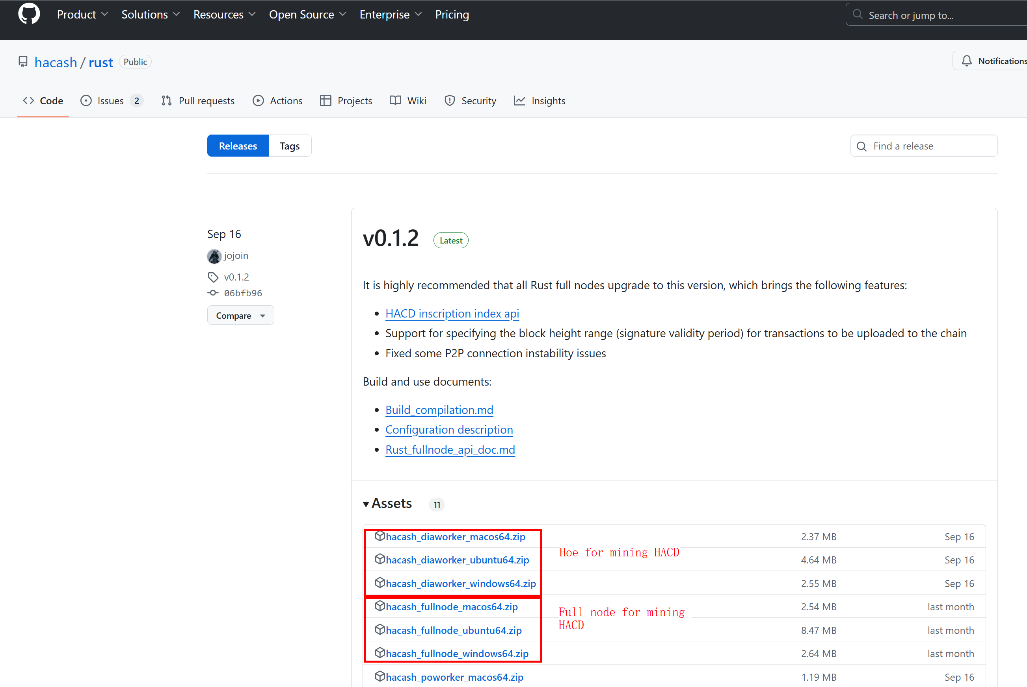

1. **Download the wallet from:** <https://github.com/hacash/wallet/releases>

Select the corresponding version based on the computer system, Here we use the wallet of the window system as a demonstration.

<Decompress the wallet software>

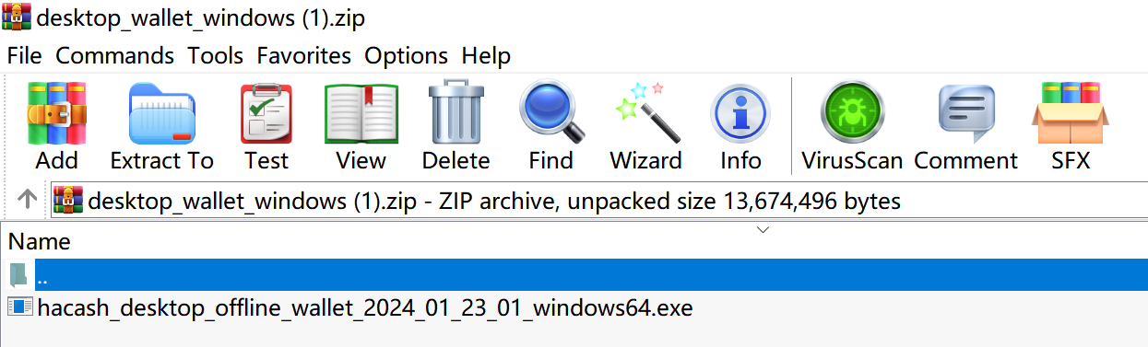

<Create account>

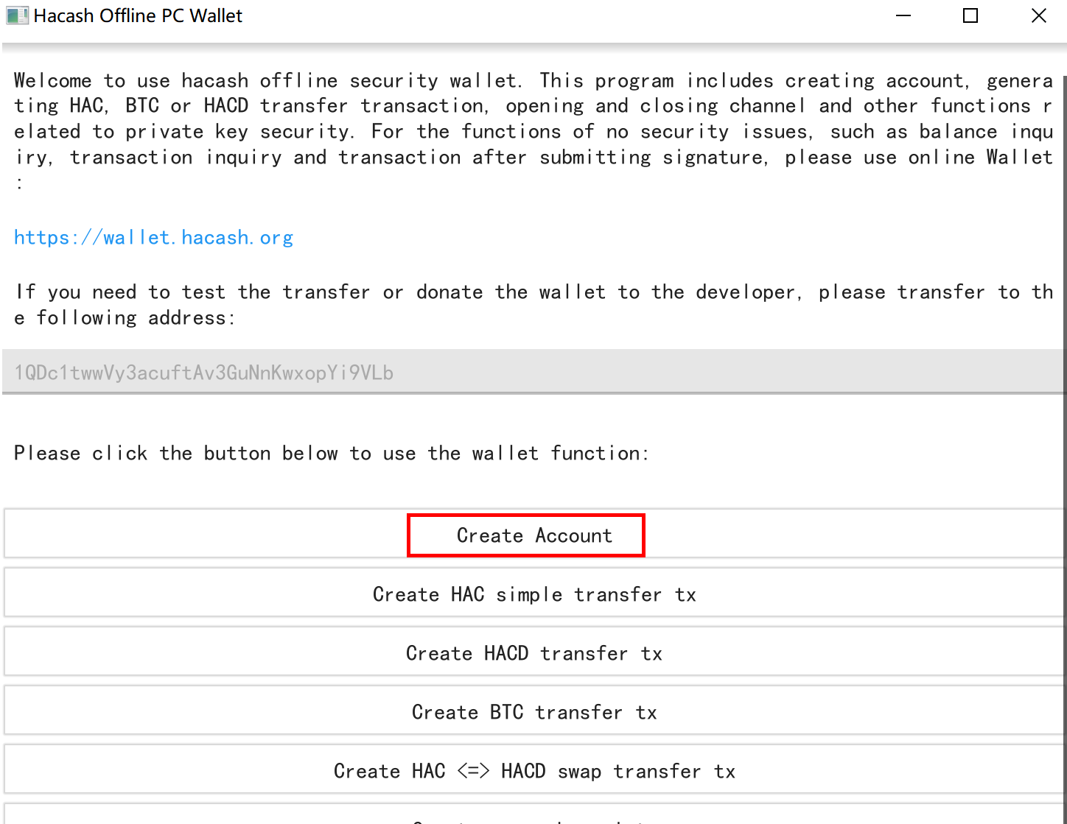

<suggested to create account randomly>

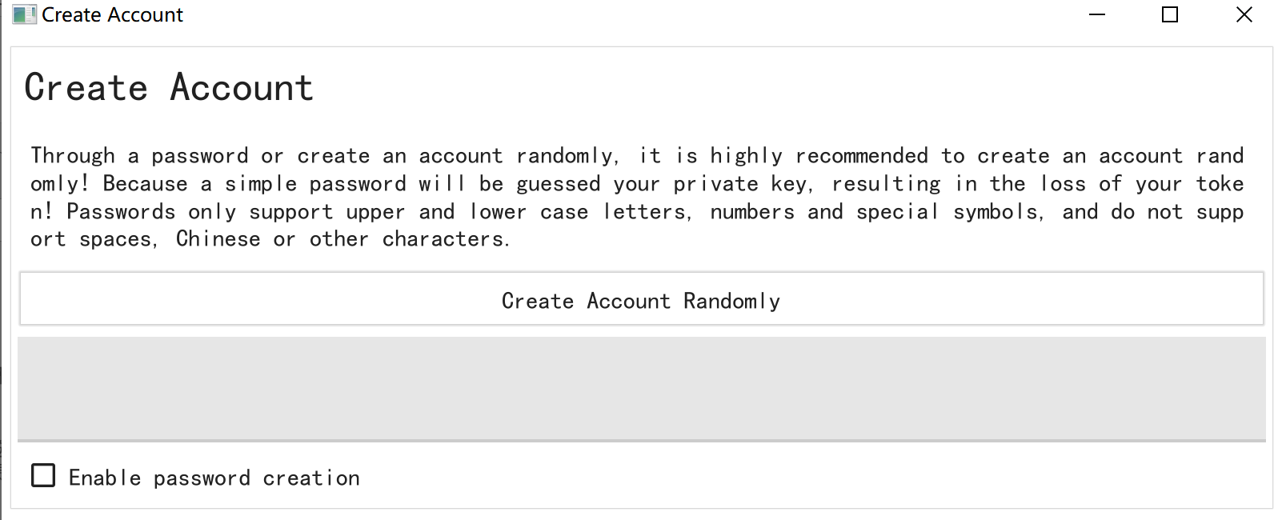

<Save the created wallet **address** and **private key (very important to you)**>

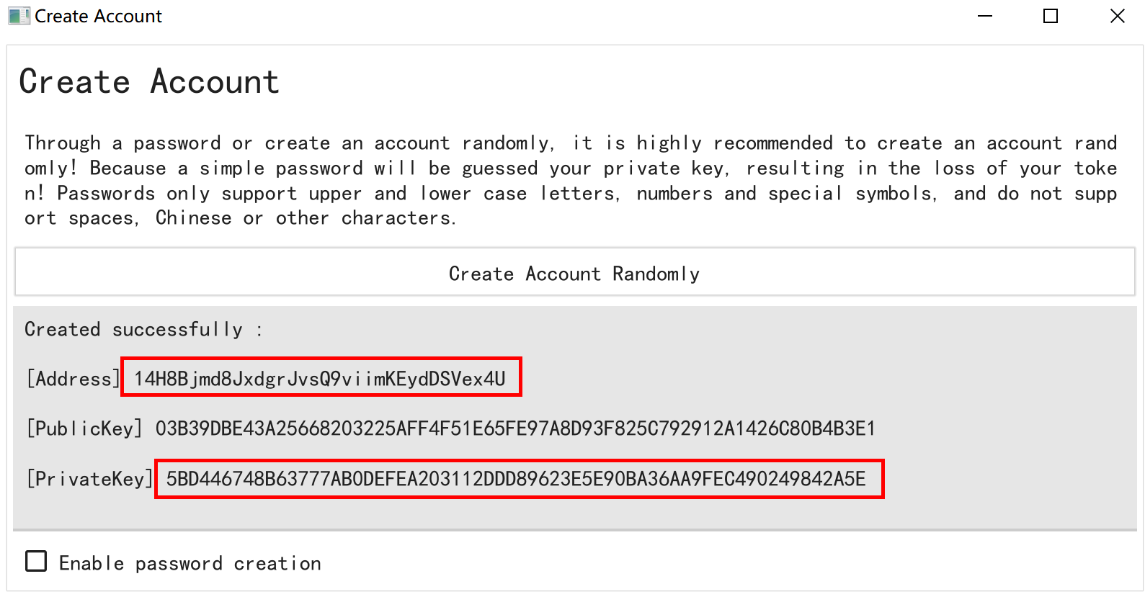

1. **Mining Profile Settings for HACD (The configuration files for Windows and Ubuntu are similar)**
2. Decompress the fullnode software and mining software to two folders (the folder can be in the same root folder).
3. For fullnode configuration, you only need to set the content under diamondminer. If the bidding fails, the HAC is not deducted. If the bidding succeeds, the HAC is destroyed.

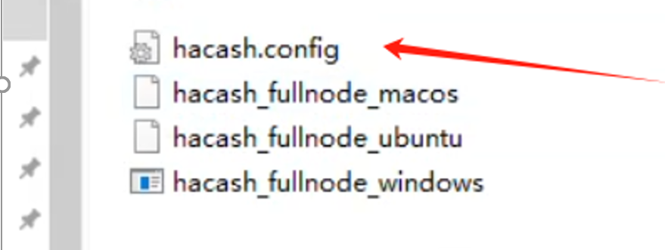

**Tips:** In each line in the hacash.config configuration file, there are spaces before and after =. Do not delete them. Otherwise, an error is reported. Do not delete the space before and after = , As shown below:

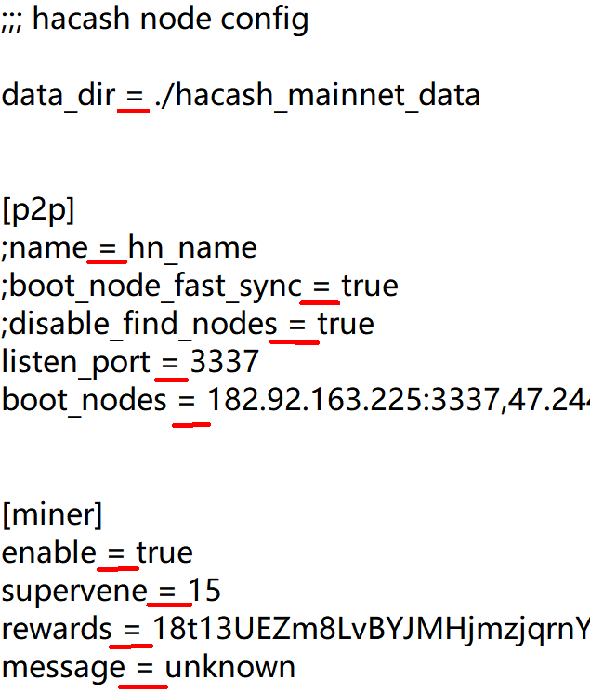

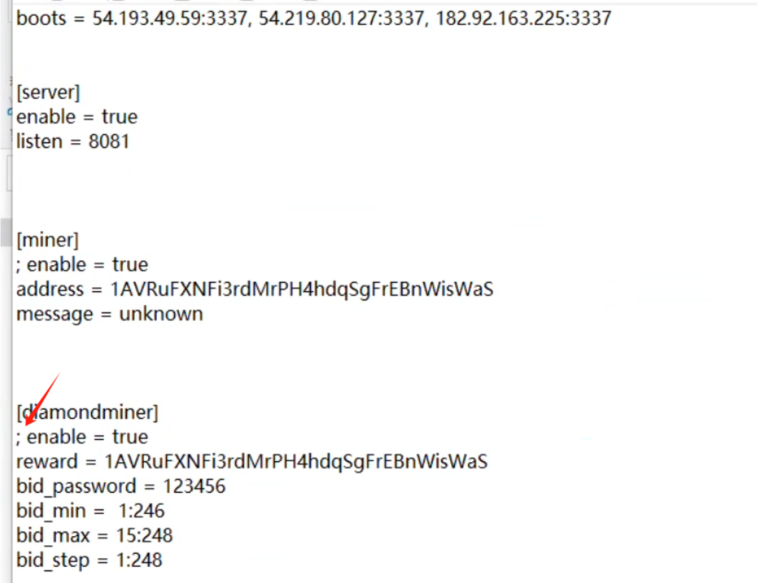

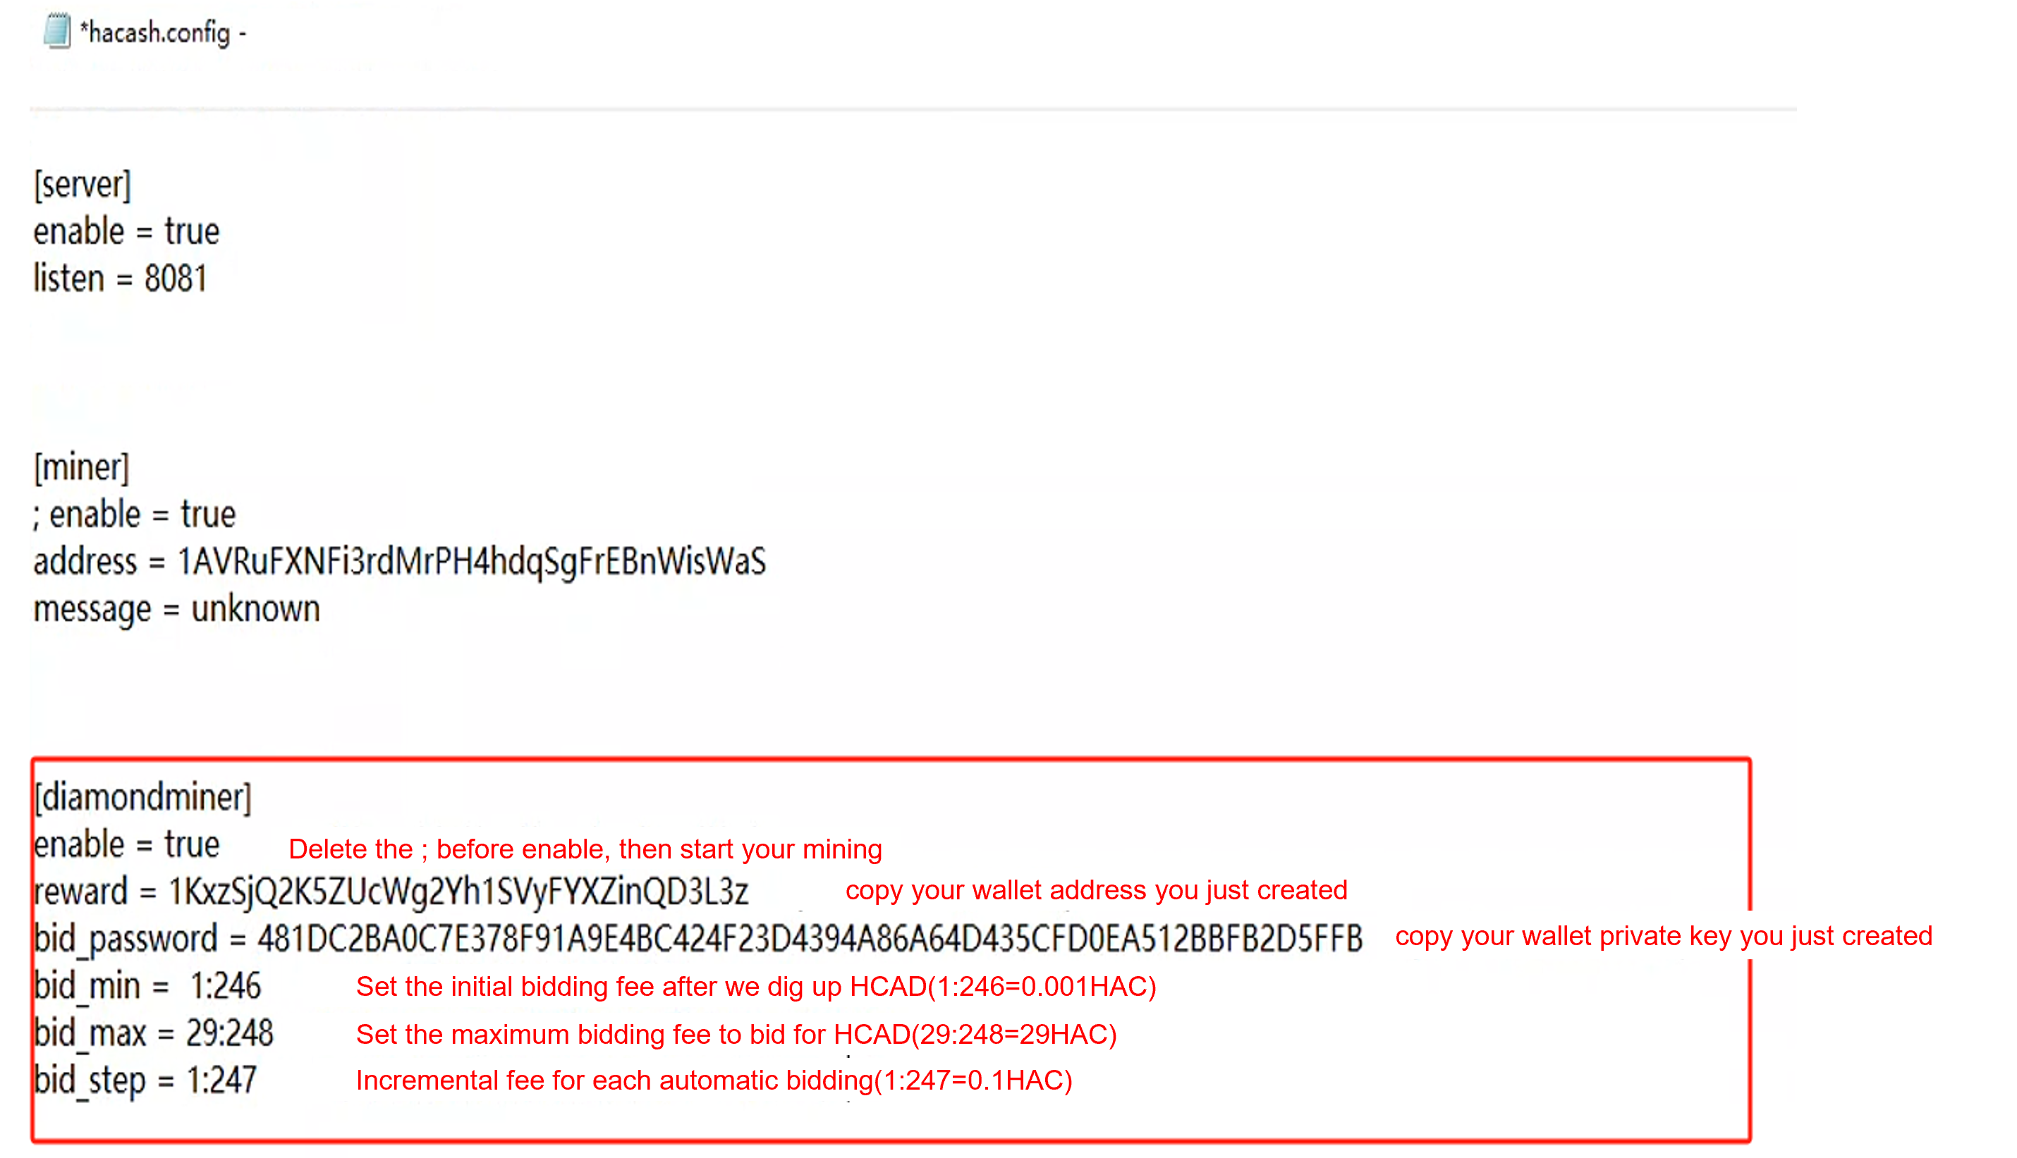

1. Setting the IP address of the miner/server in different scenarios

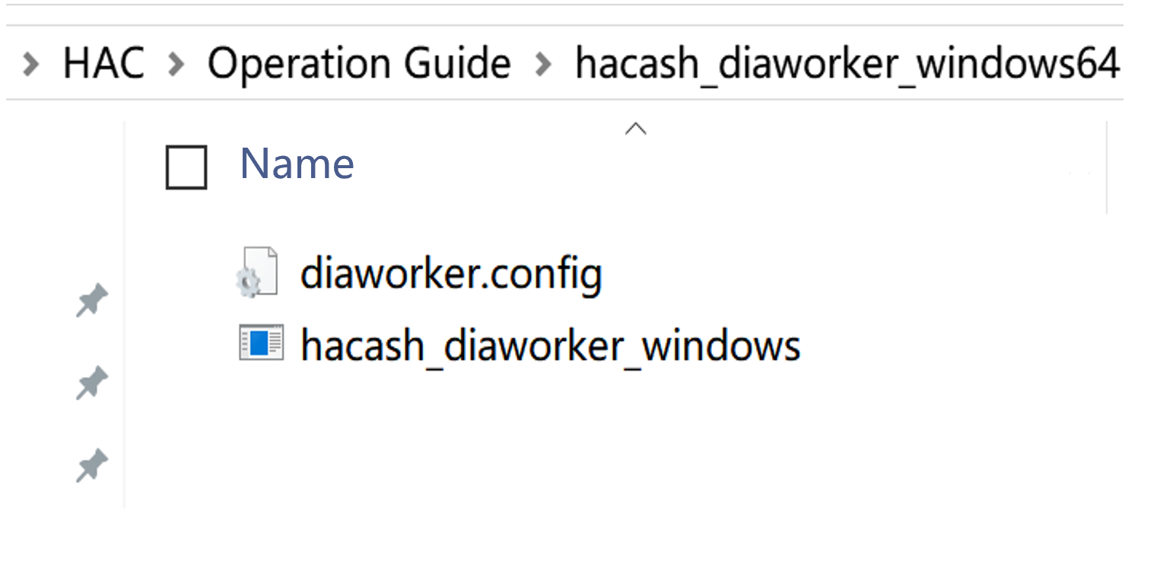

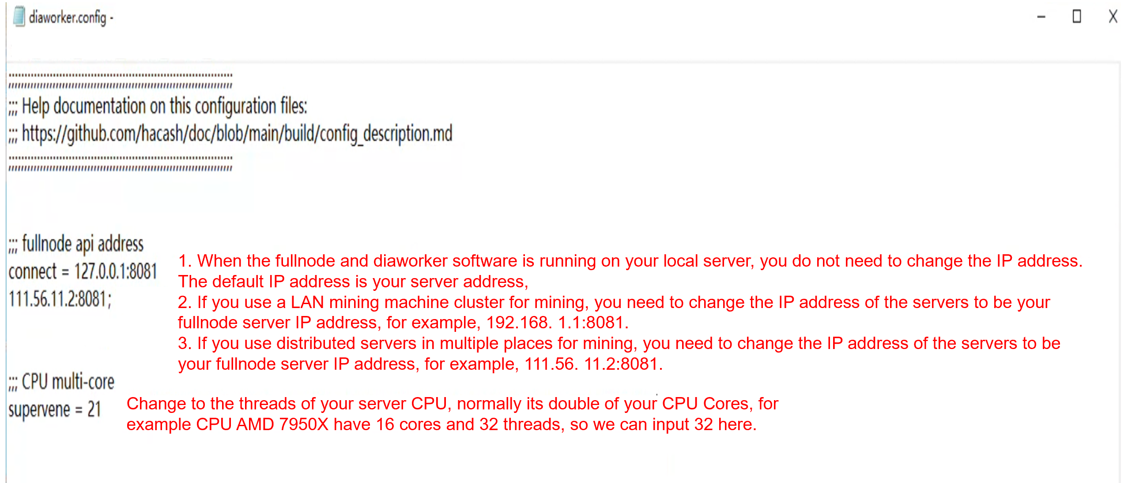

<Running fullnode and mining software>

* If the downloaded package is a Windows operating system, run the .exe file as an administrator,
* If the downloaded package is Ubuntu, enter the following file path:

**For fullnode configuration, please input：**

chmod 777 hacash_fullnode_ubuntu && nohup ./hacash_fullnode_ubuntu &

**For diaworker configuration, please input：**

chmod 777 hacash_diaworker_ubuntu && nohup ./hacash_diaworker_ubuntu &

**Tips:** Ubuntu miner can also be connected to Windows fullnodes, and Windows miner can also be connected to Ubuntu fullnodes.

1. **How to Get Fuel for Digging HACD：HAC**
2. Visit hacash.org for HAC mining tutorials (Not recommended. It is officially released as a CPU hoe. Currently, some miners use efficient GPU hoes. Therefore, CPU hoe mining is not competitive.)
3. Log in to Xeggex.com Exchange and search for HAC to buy and withdraw cash to the mining wallet address
4. **Query mining revenue**
5. Block Brower：<https://explorer.hacash.org/?lang=en-US>
6. Copy the mining wallet address to the block browser and click Query.

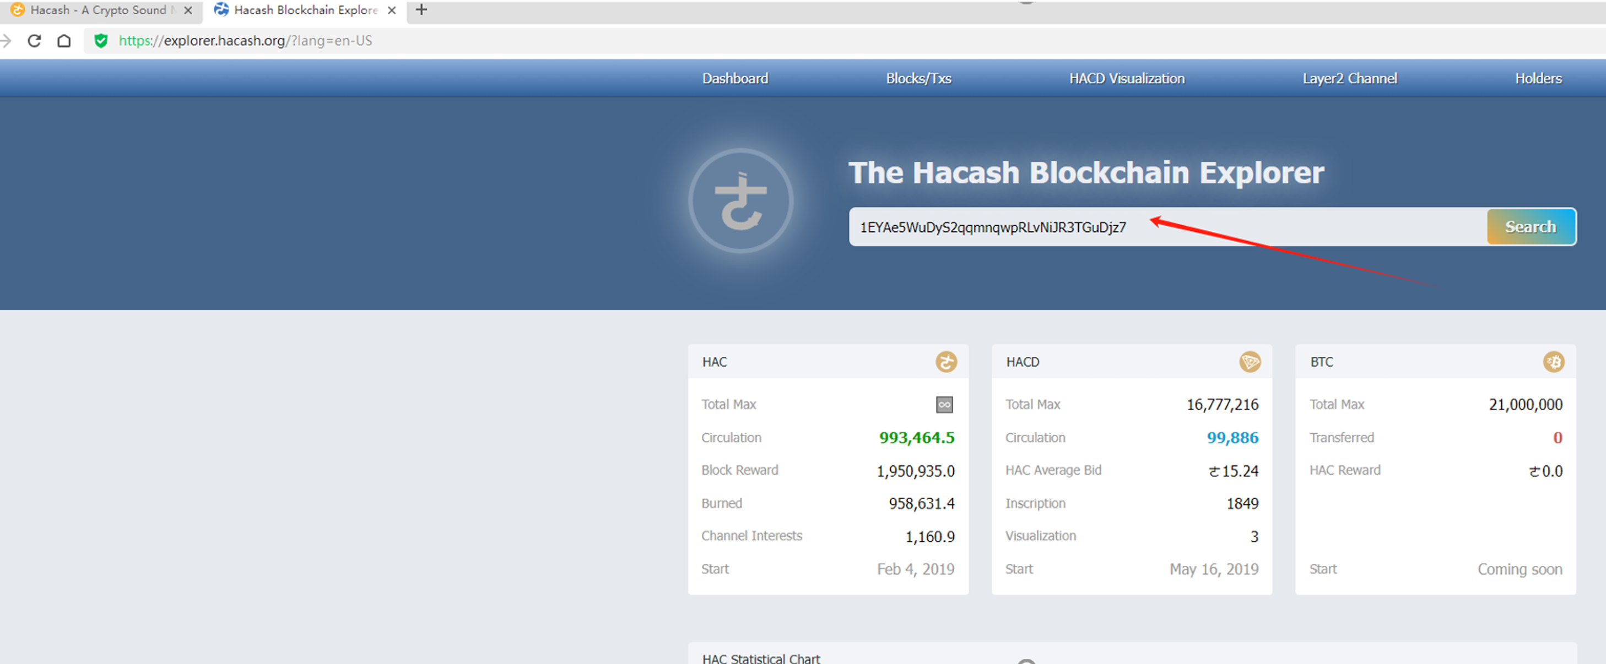

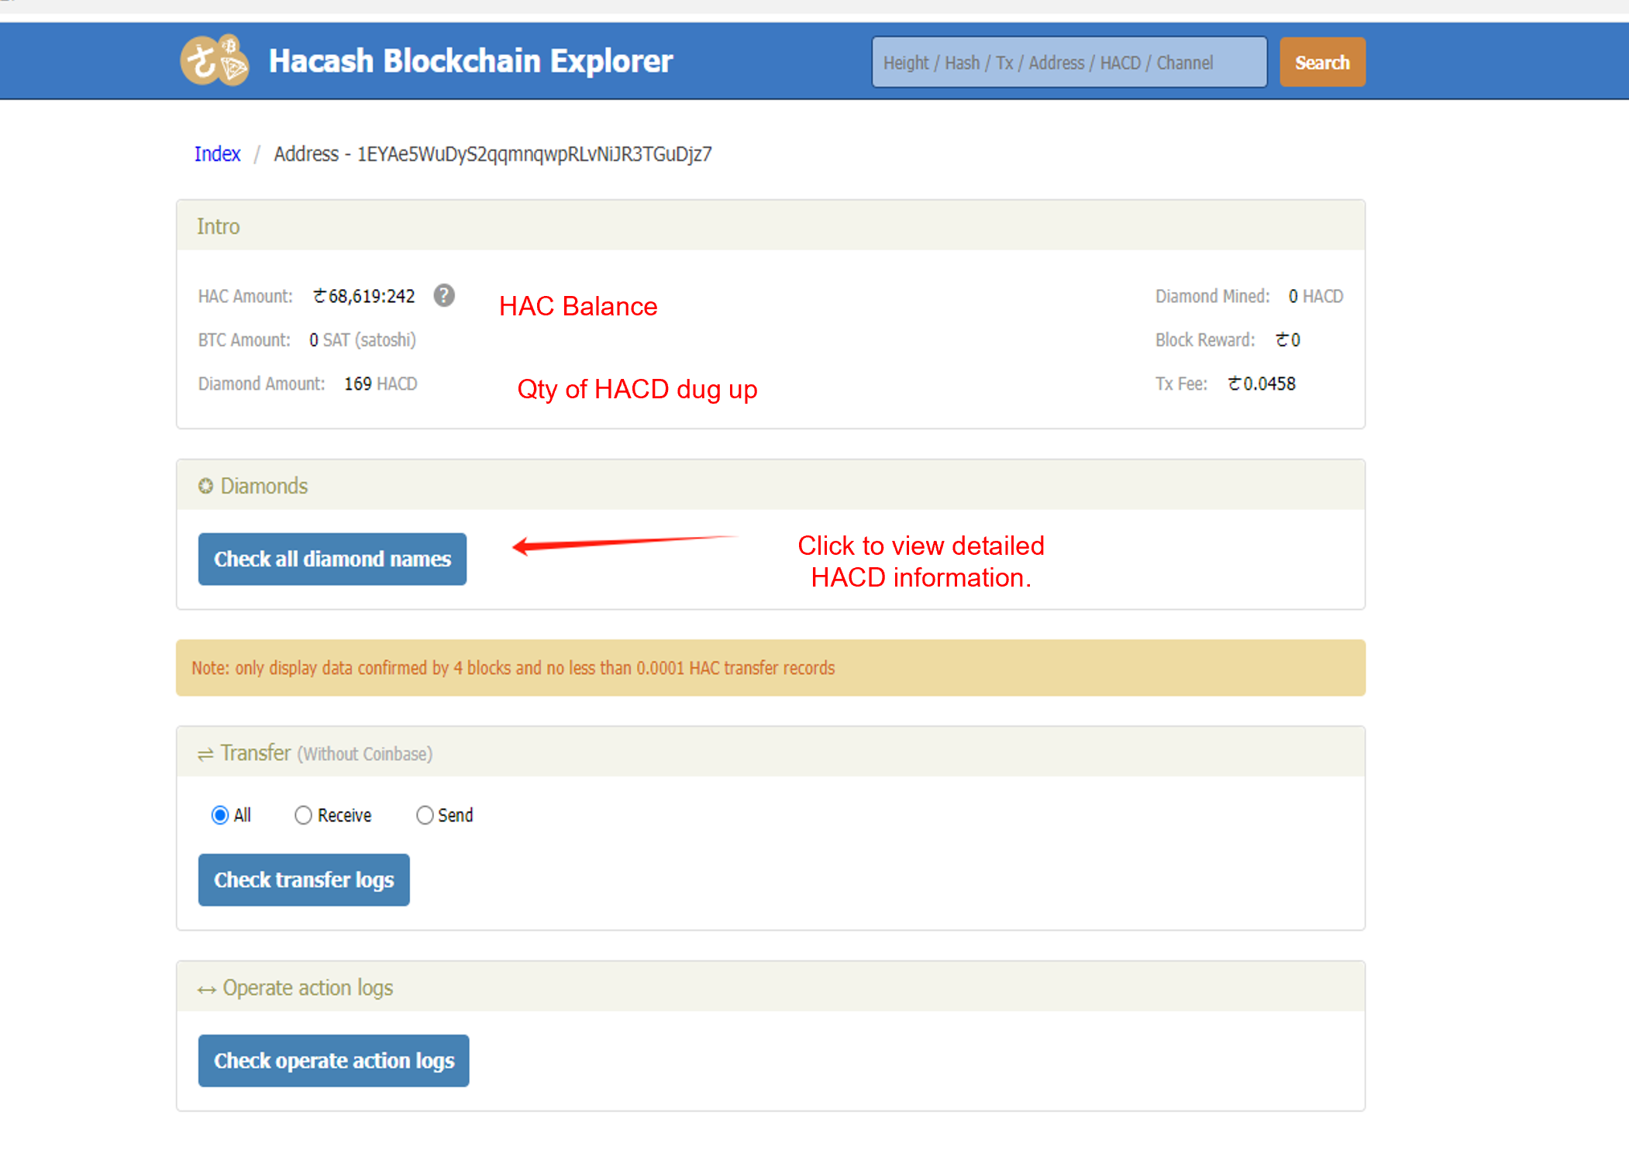

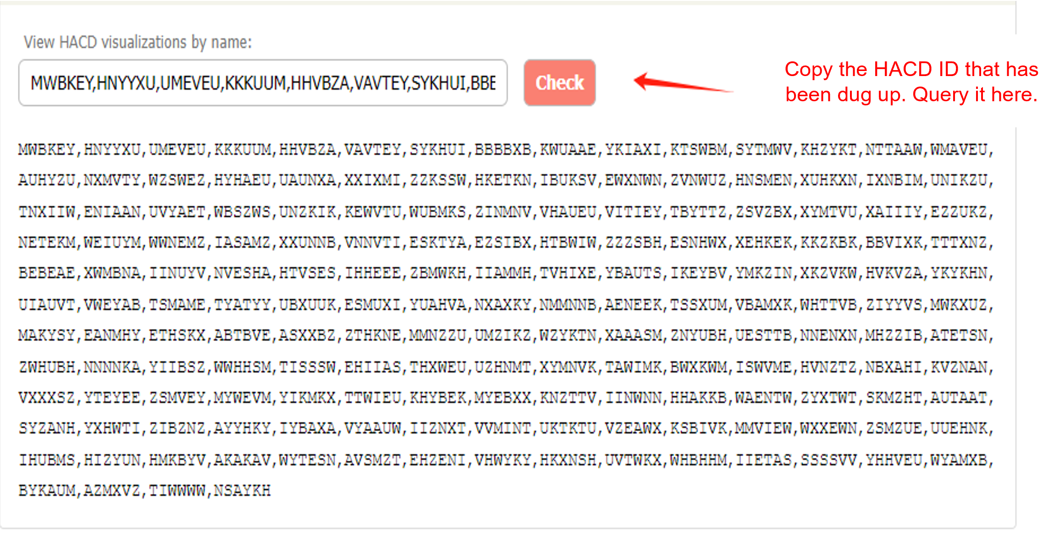

<Here are your exquisite diamonds and details>:

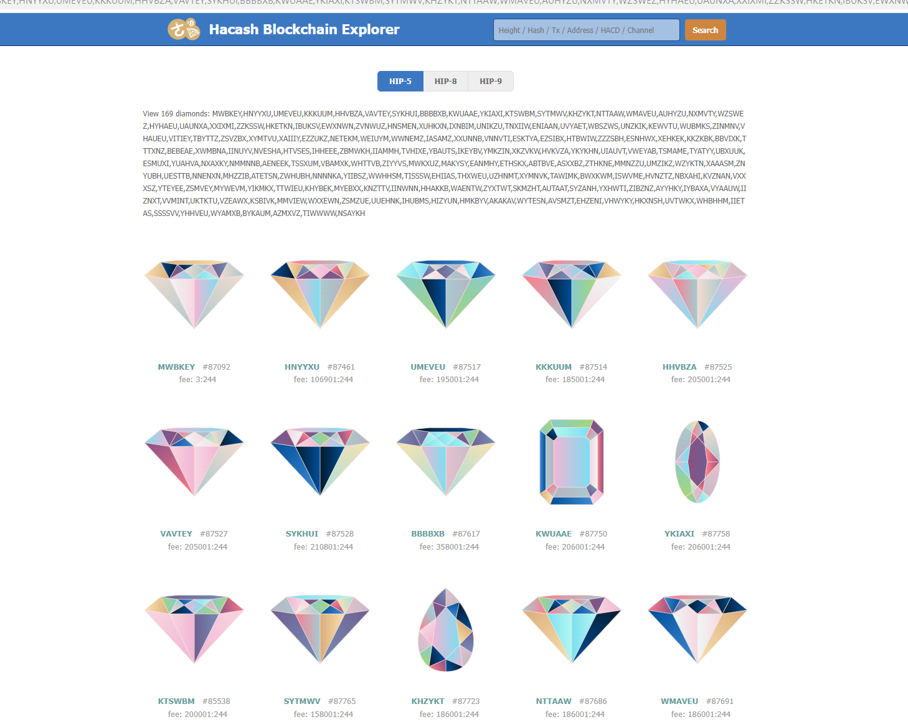

1. **hacds inscription**

(For details about the proportion of 1 HACD : xx hacds, you can visit hacds.me. For normal diamonds, inscriptions are not recommended.)

Recommended Inscription Enquiry Website: hacd.fun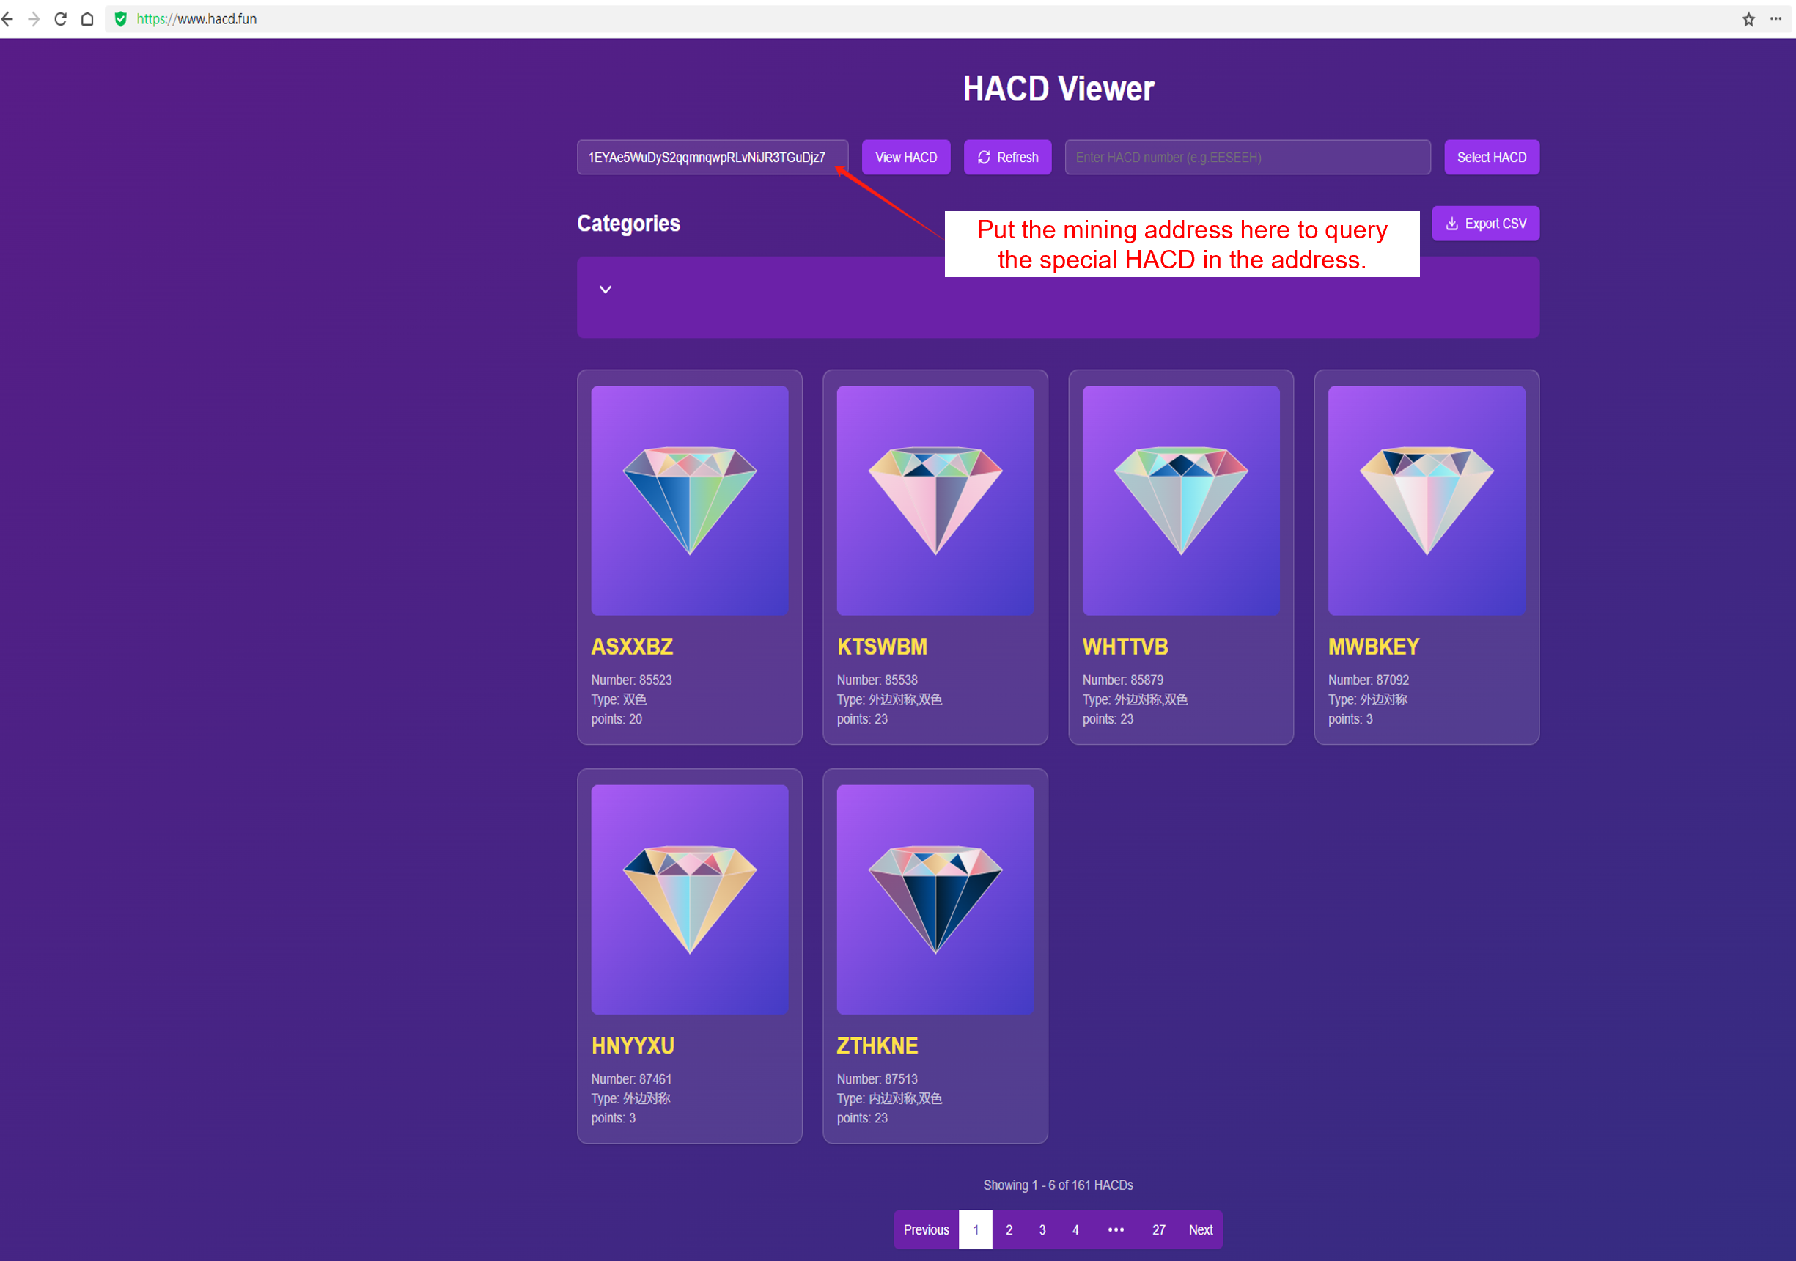

1. Use offline wallet for hacds inscription

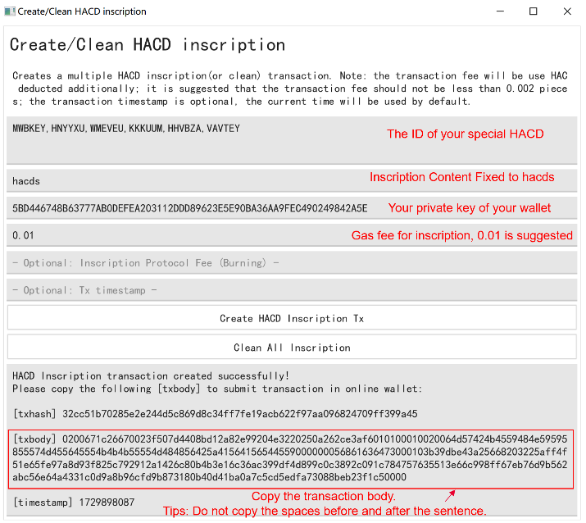

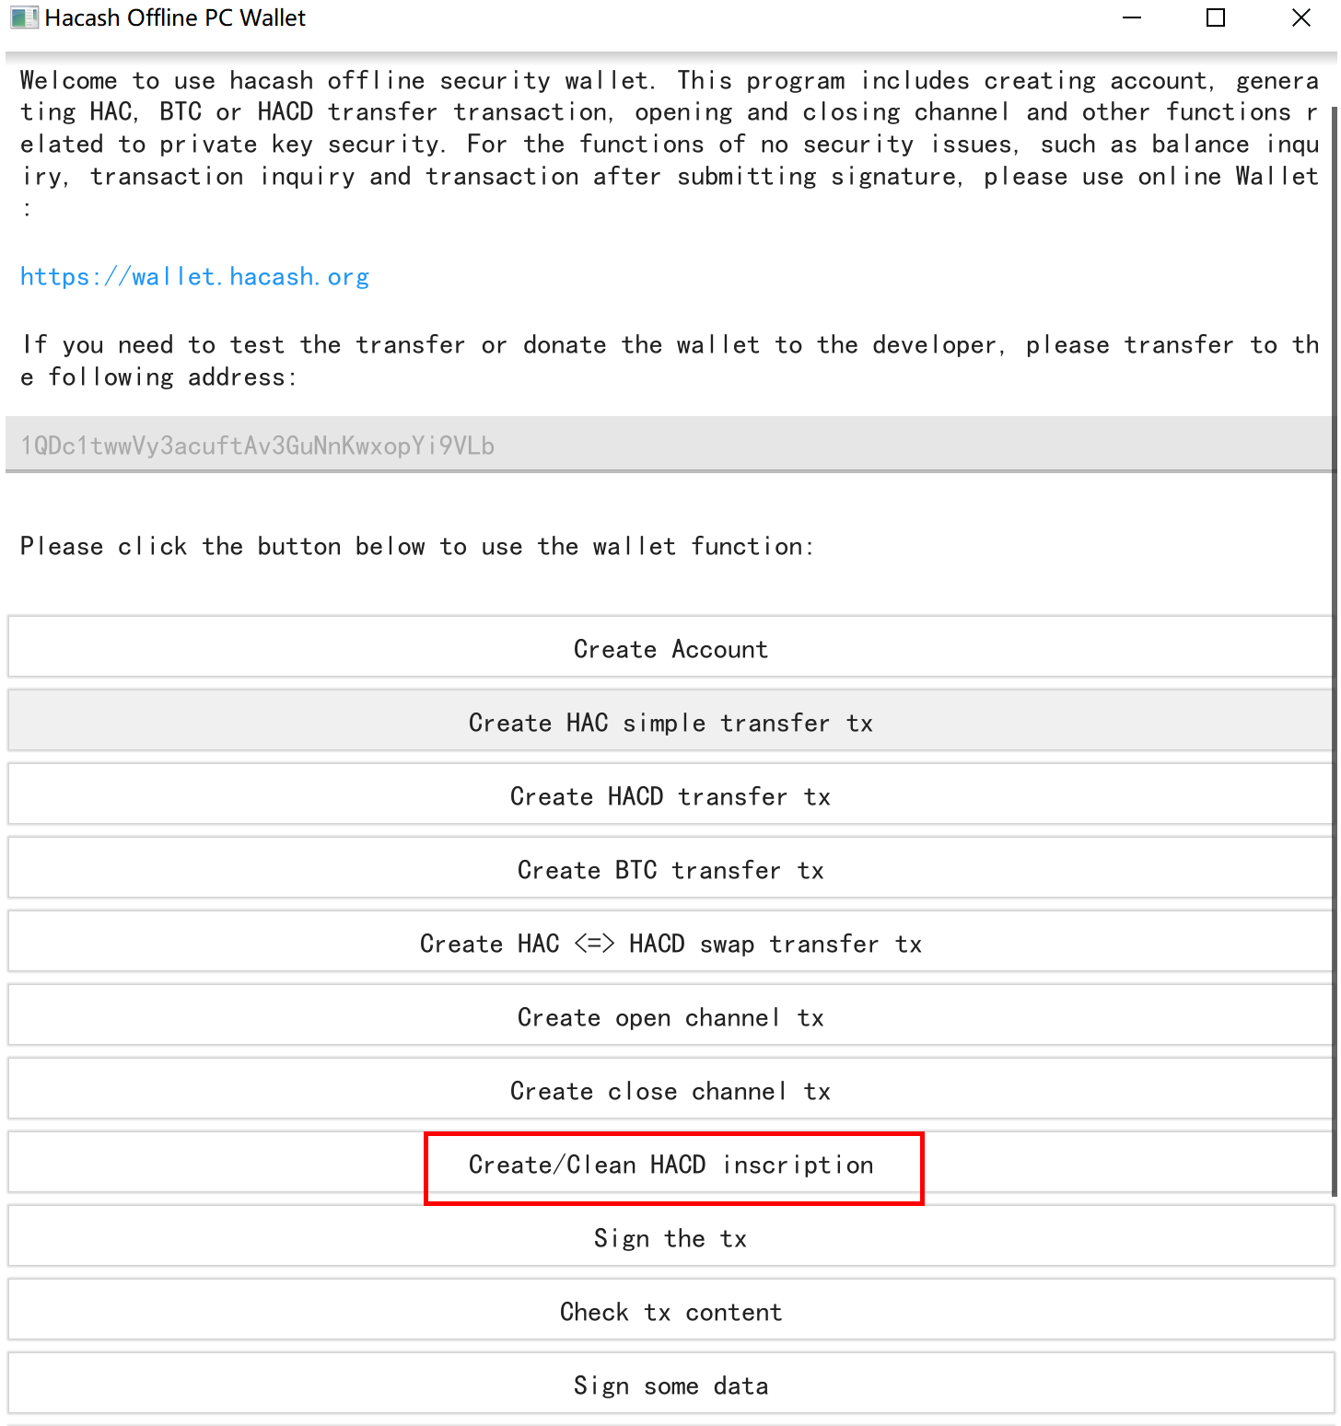

1. Submit inscription information to hacash main network

Open online wallet website: <https://wallet.hacash.org/?lang=en-US>

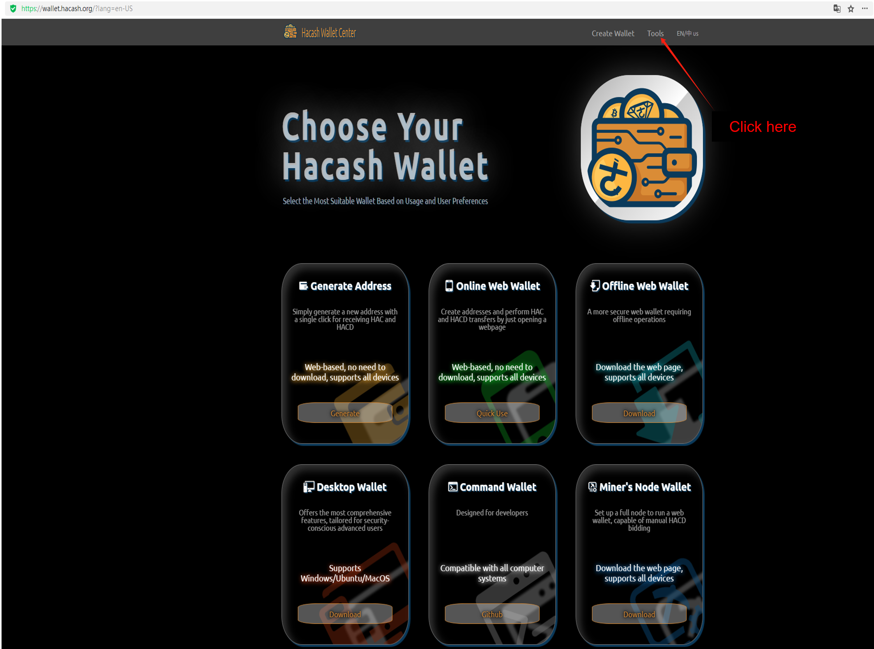

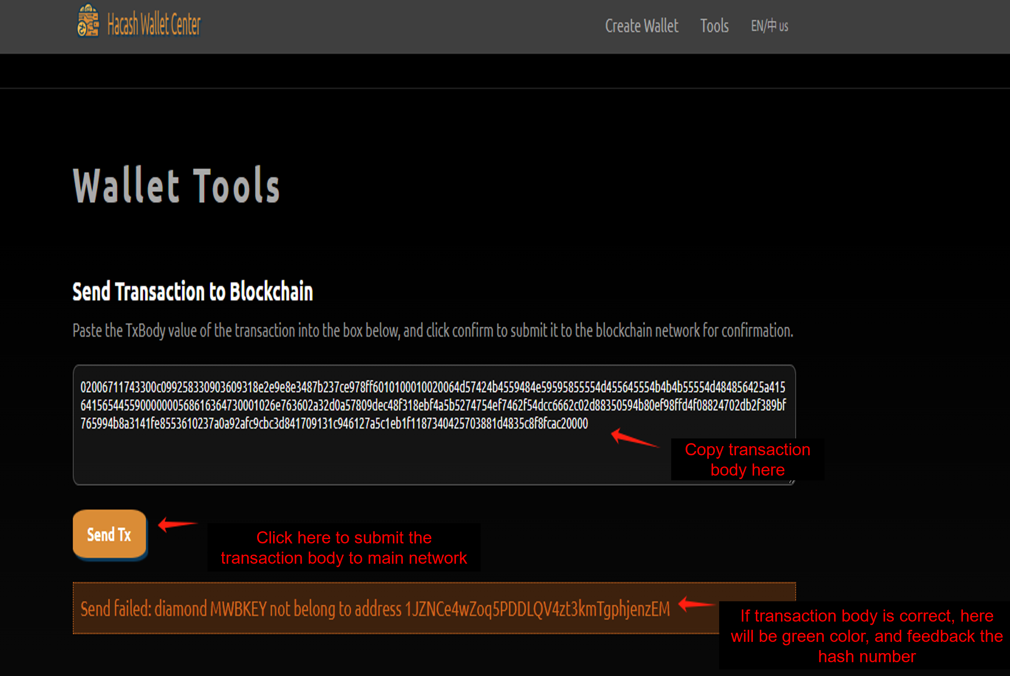

1. **After the inscription is complete, click each HACD to view the inscription information.**

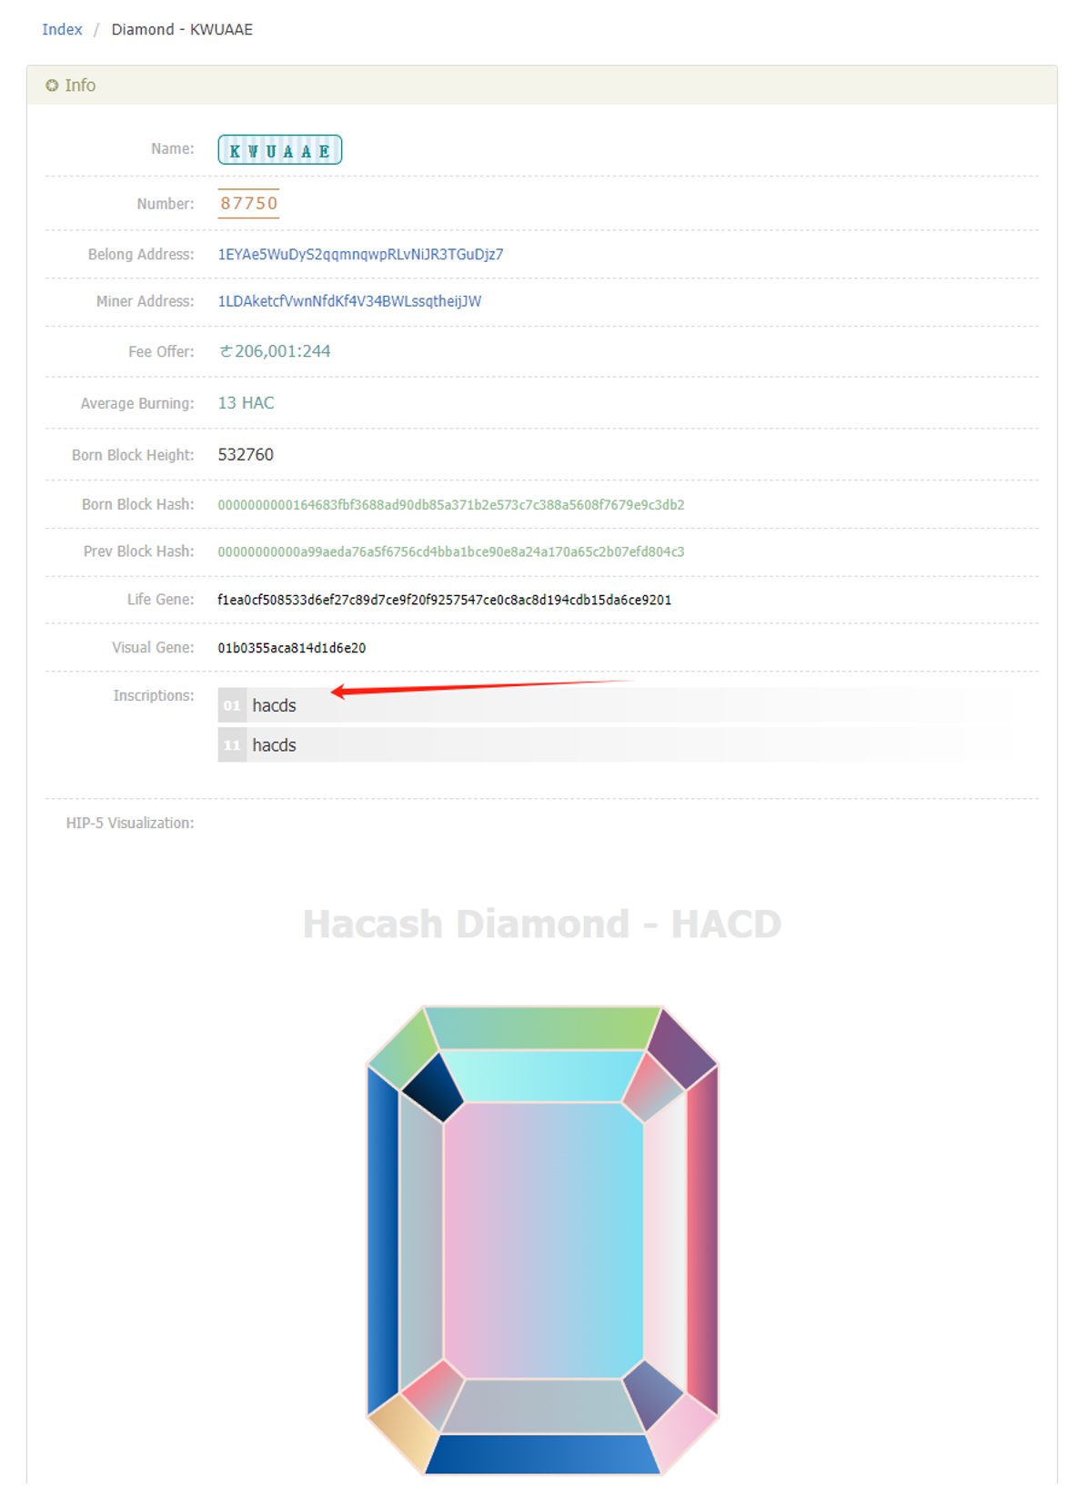

<You can use the online API to query the number of HACD corresponding to multiple HACD, A maximum of 20 HACD can be queried at a time>：

<https://www.hacds.me/hacds/diamond/queryDiamond?names=MWBKEY,HNYYXU,UMEVEU,KKKUUM,HHVBZA,VAVTEY,SYKHUI,BBBBXB,KWUAAE,YKIAXI,>

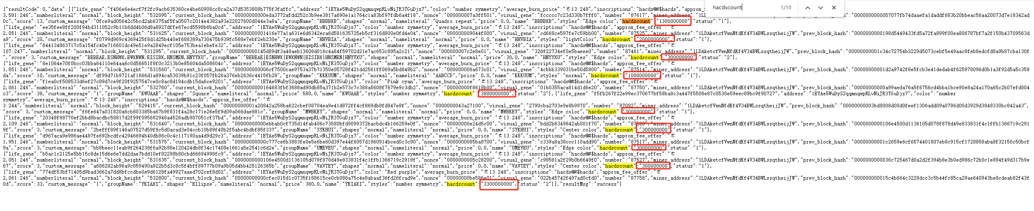

1. **Transfer of HACD and hacds**
2. HACD and hacds share the same recharge address (xeggex and nonkyc). If no hacds inscription is made for HACD, the HACD asset quantity is recorded in the balance. If there is hacds inscription, the hacds quantity is recorded in the balance.
3. Use the offline wallet to transfer money.

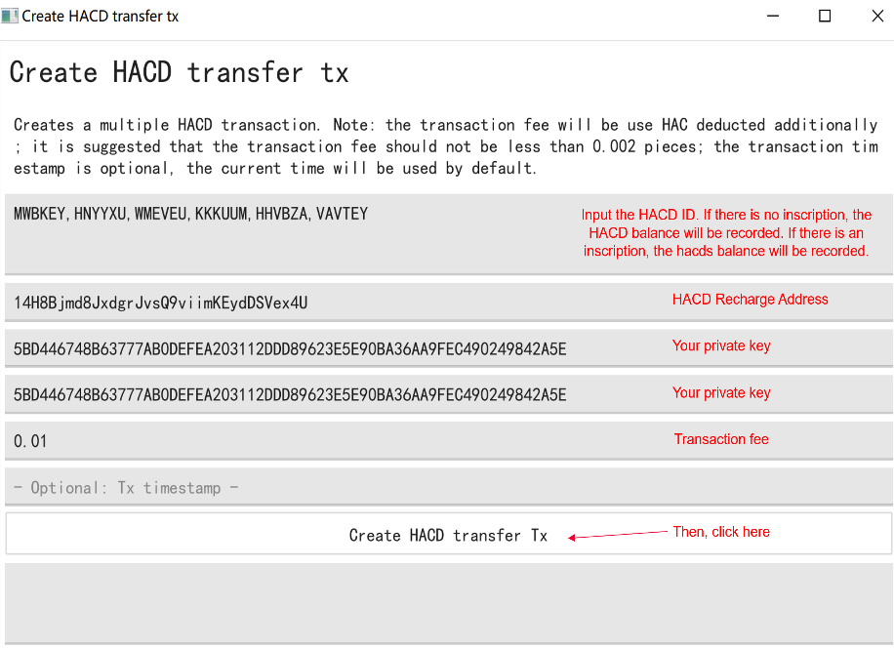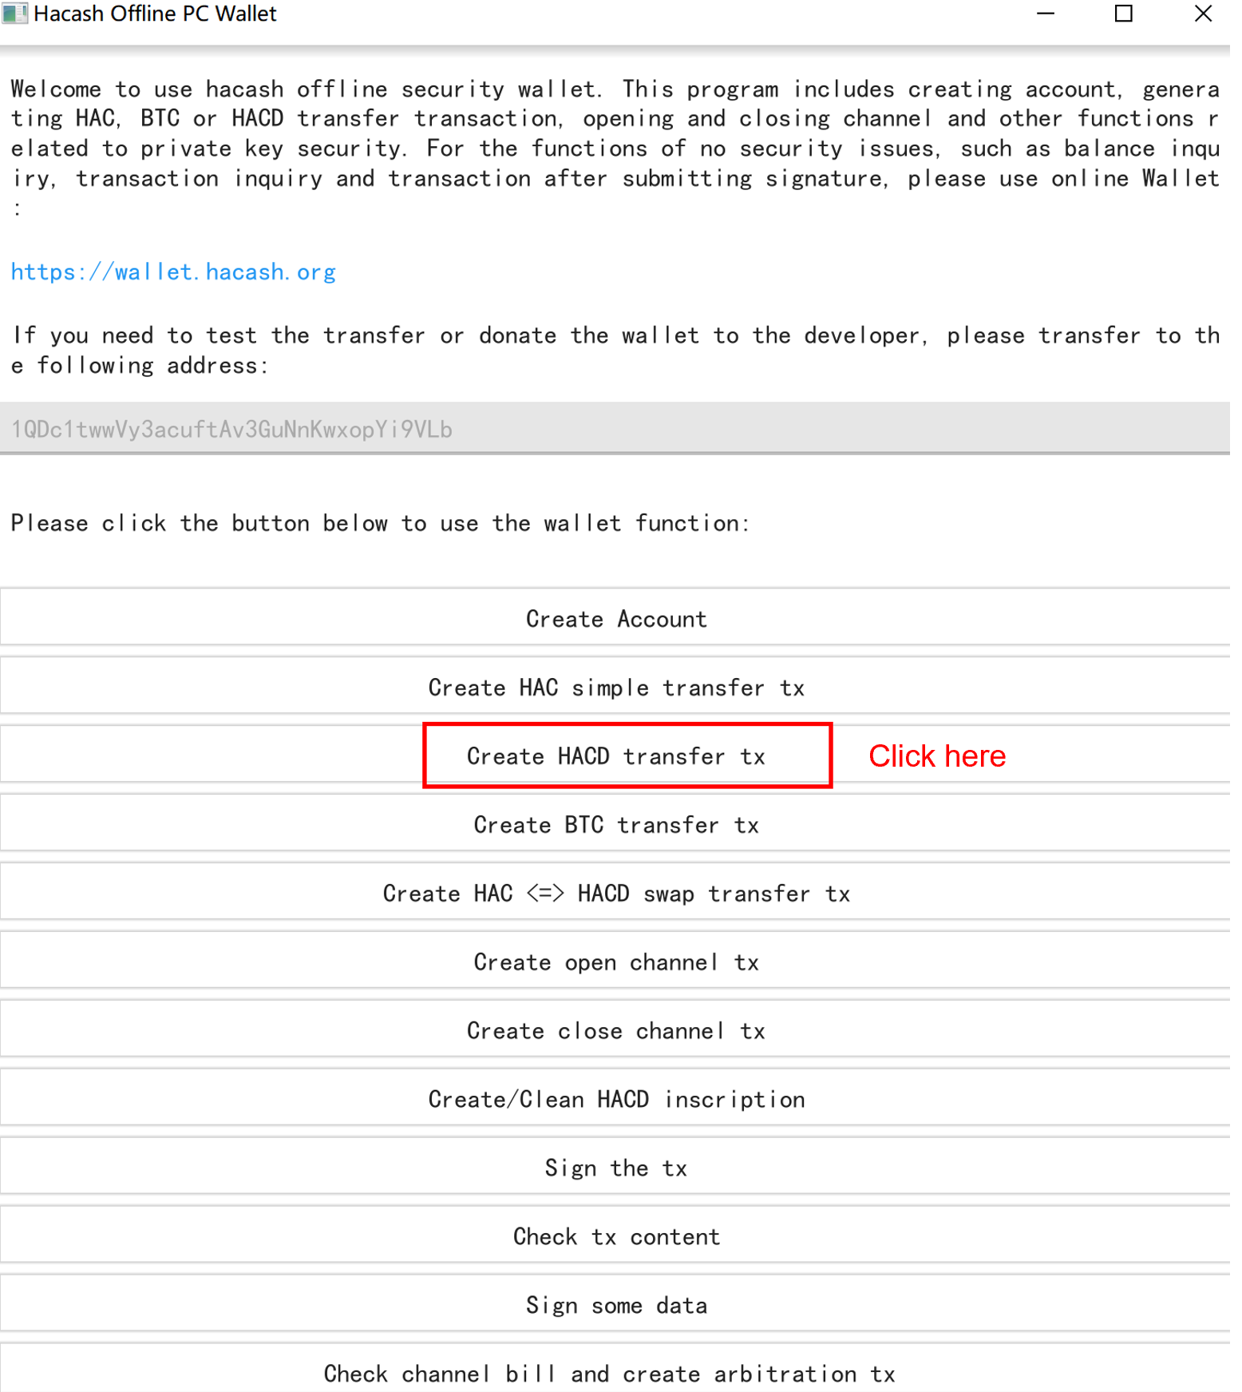

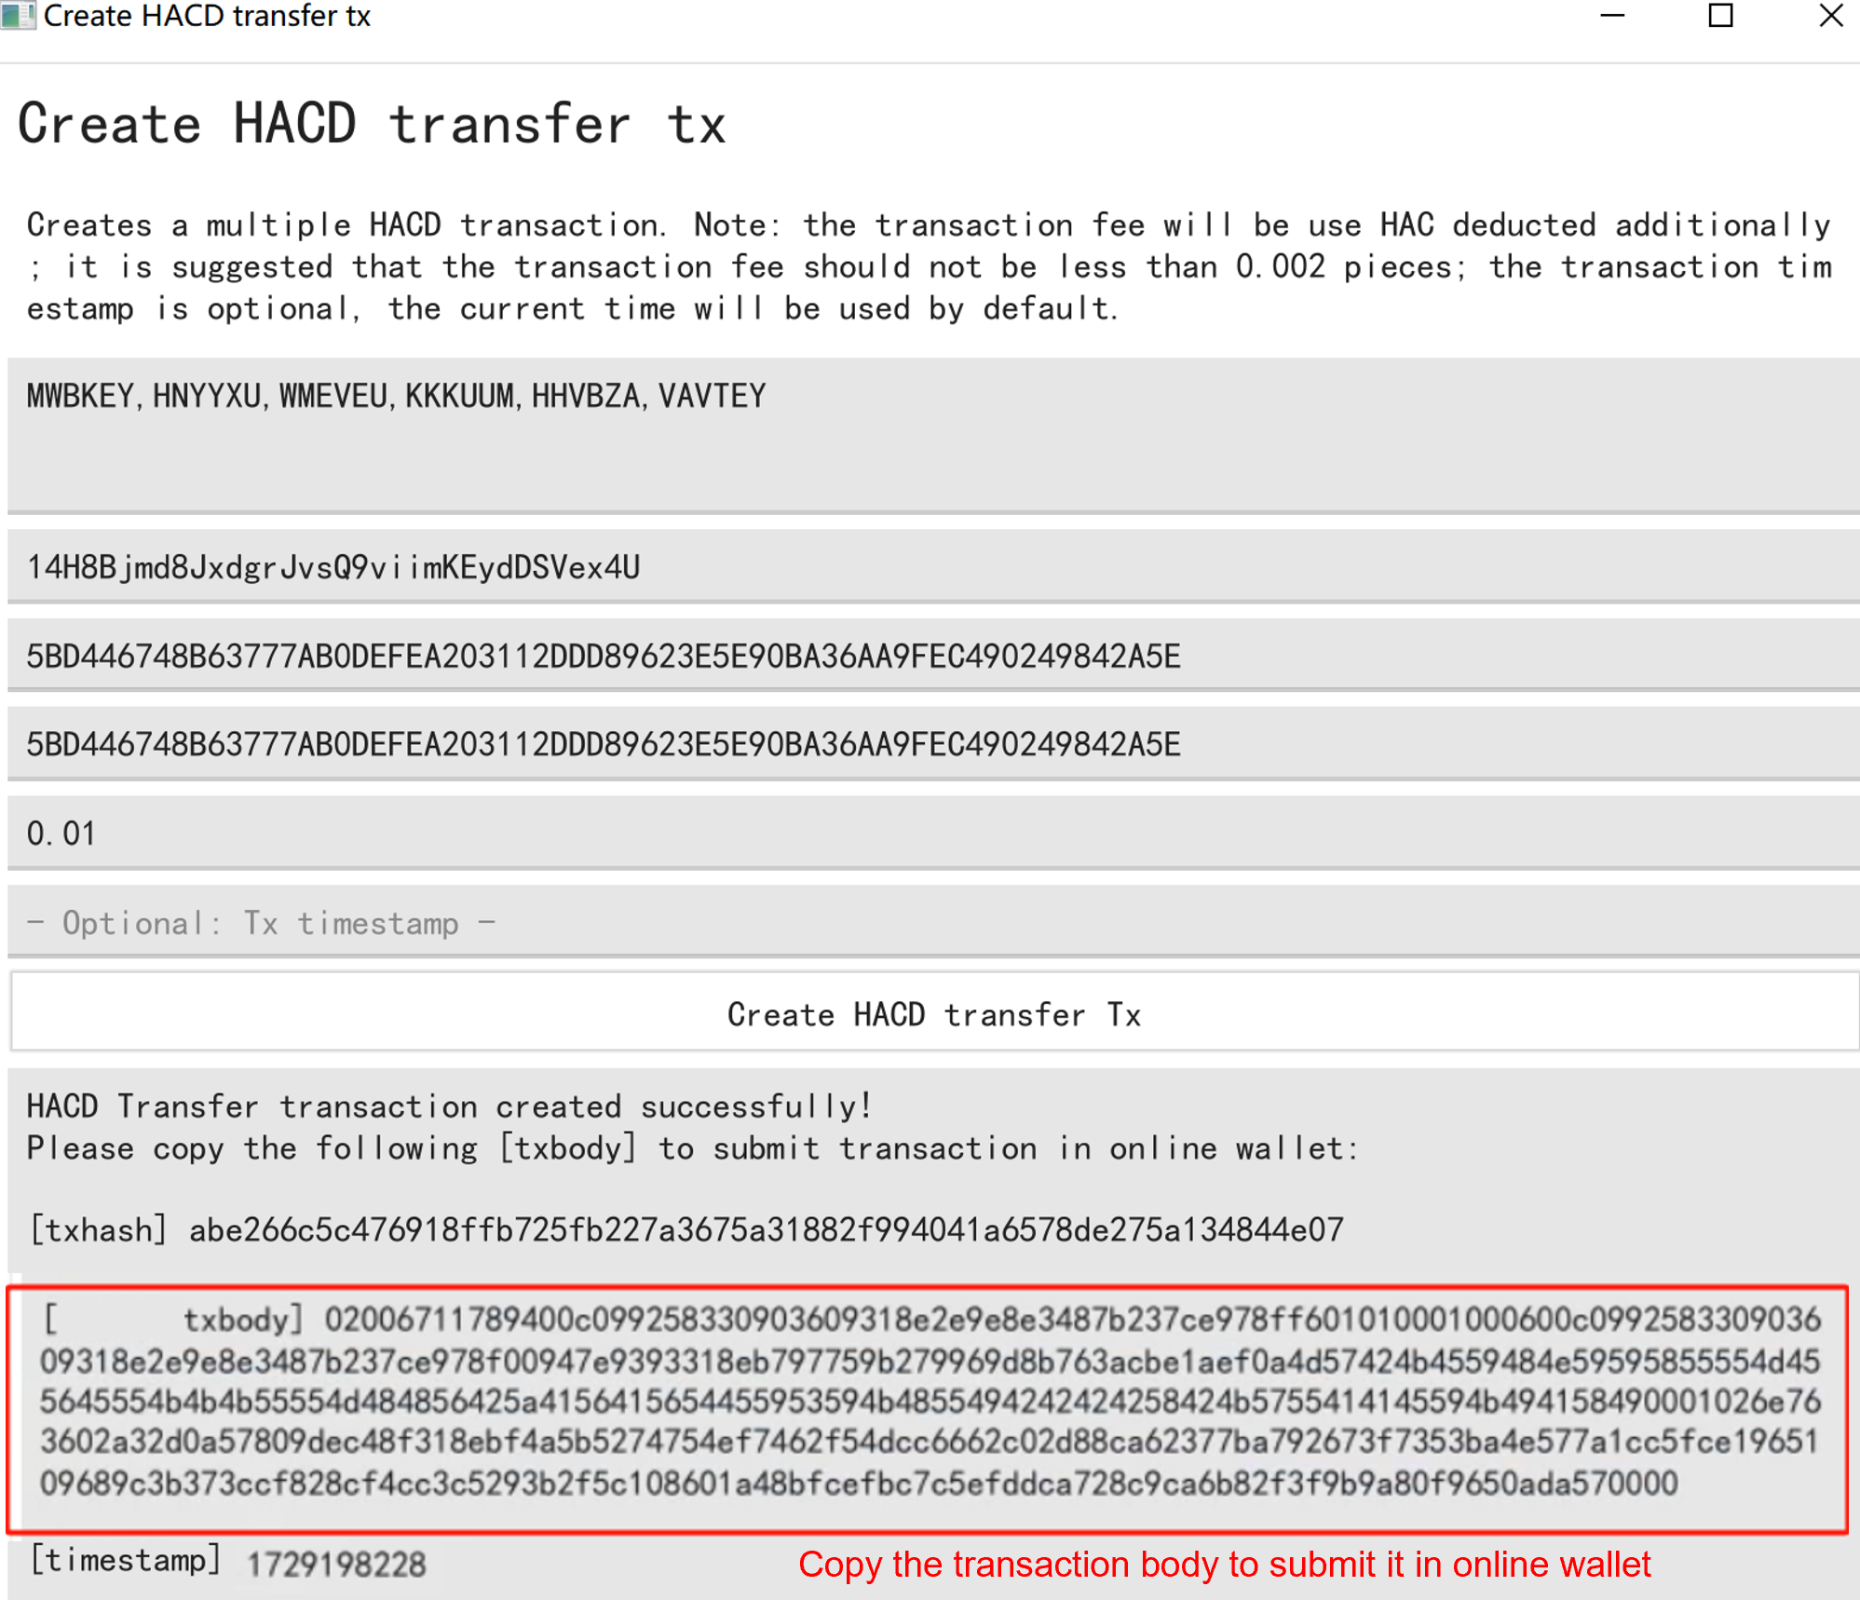

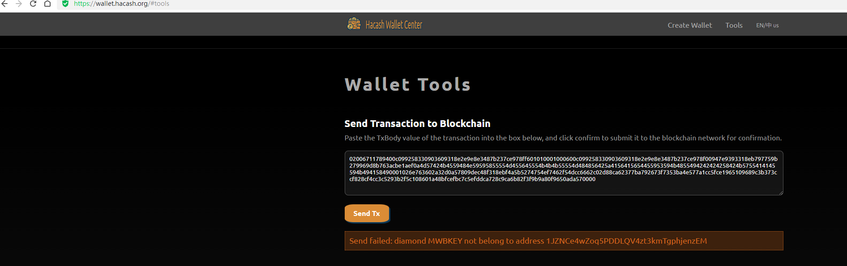

1. Transfer money by online wallet: <https://wallet.hacash.org/>

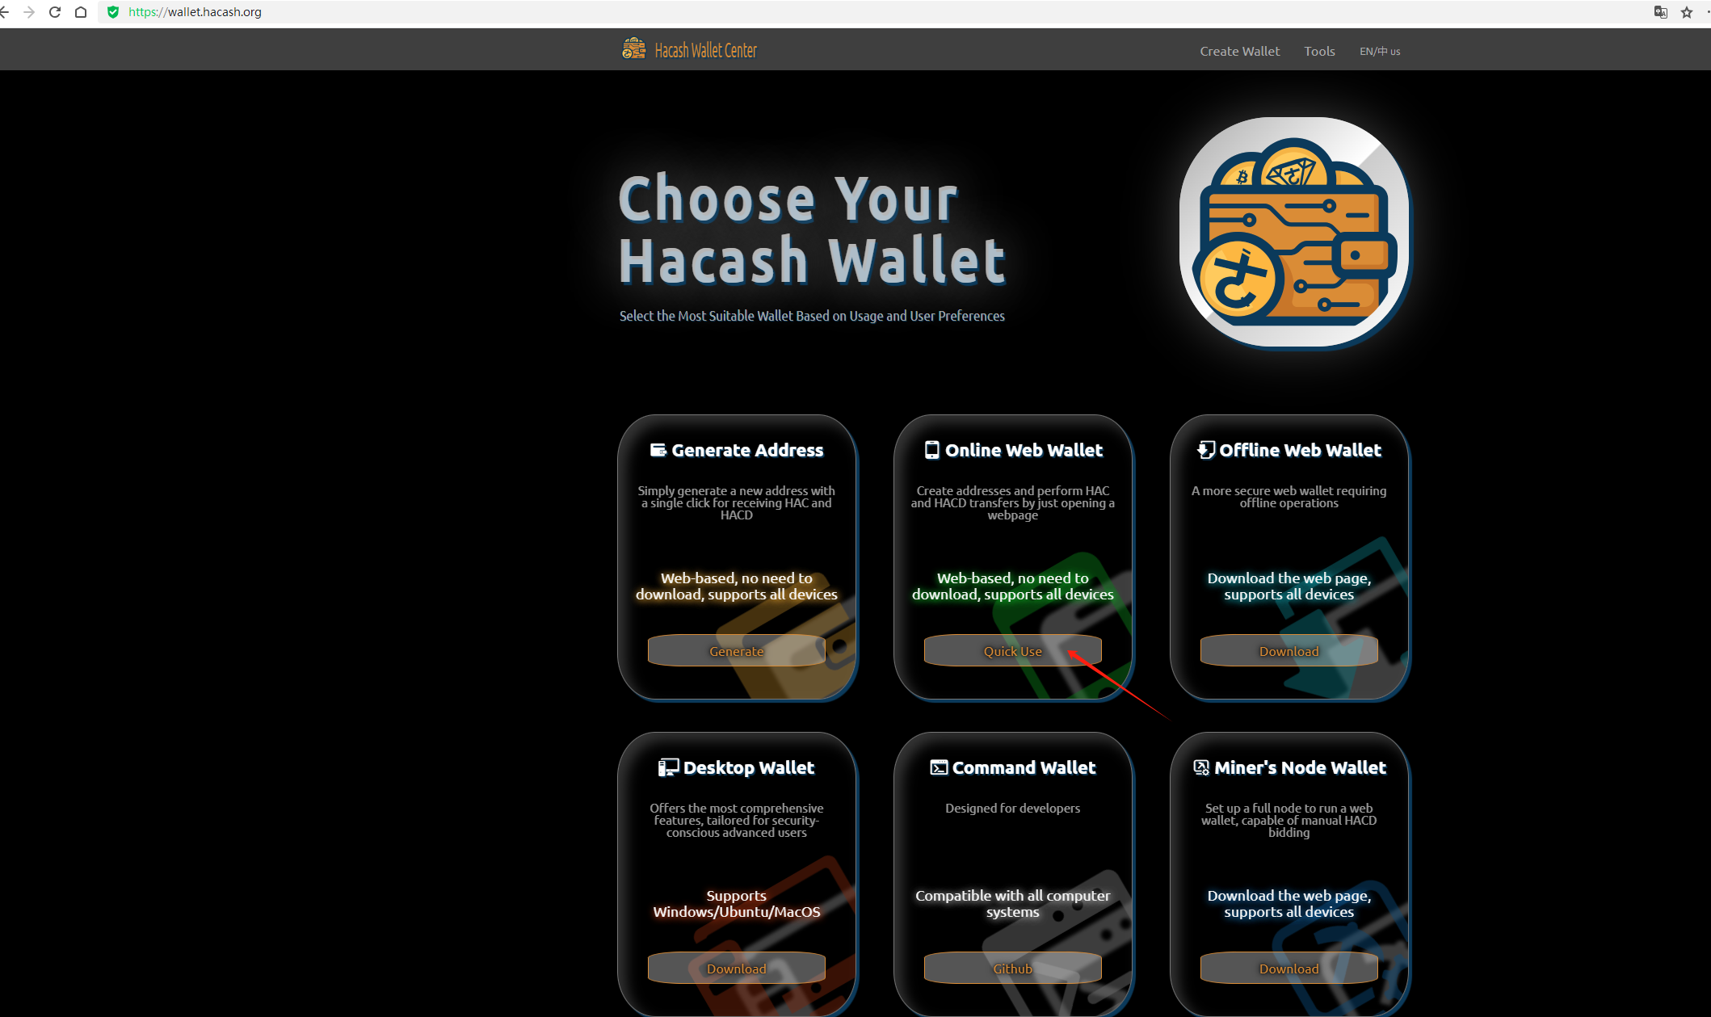

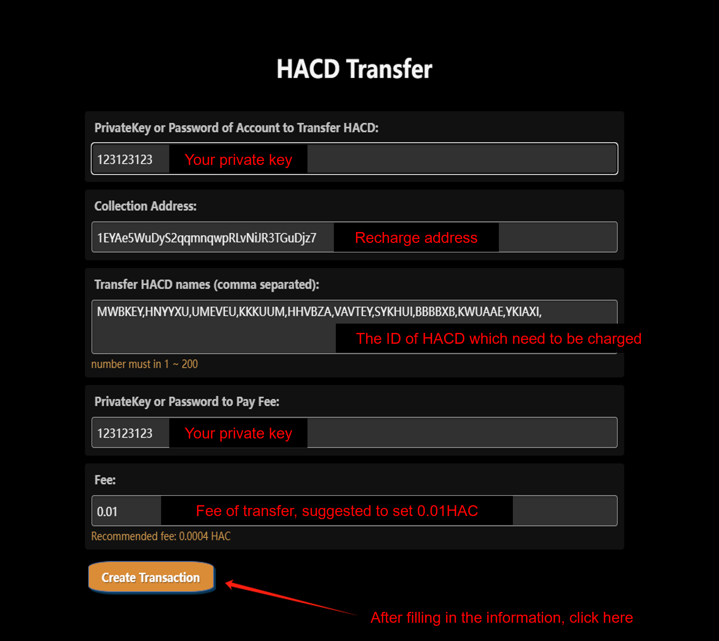

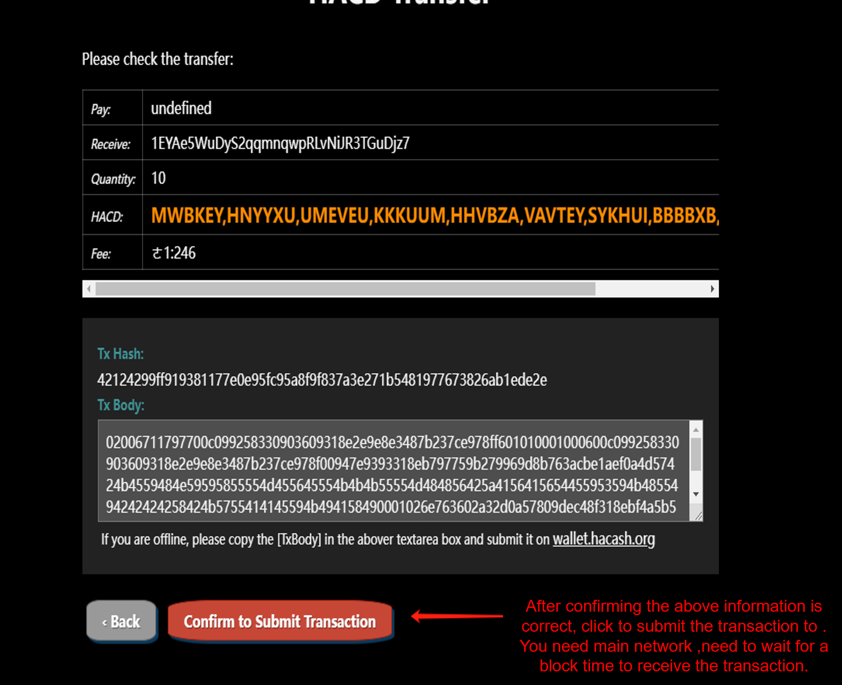

1. **hacds Mining Recommendations**
2. The normal HACD are not suggested to do hacds inscription, but only special HACD.
3. Sell normal HACD and hacds, and replace them with HAC for cyclic mining. (Only if the number of HAC purchased can offset the number of HAC consumed by mining.)
4. Sell excess hacds to obtain USDT. If USDT profits can cover the cost (electricity, equipment, and hac costs), You can hold your hacds and keep an eye on hacds market.